Process:

.cpp program -> compile = executable file .exe (platform dependent)

Exe file-> double click = process

Process – Program Under execution (it comes into RAM from memory for execution)

Thread(light Weight Process) :

Consider big application having many programs, having functions

Thread can execute independently

Subtask of process such as storing details on cloud independently

Eg: JPG to PNG

100\*100 img JPG -> LOGIC - > 100\*100 img PNG

Divide process asynchronously so that they converted independently/ paralleled

Sequential execution takes t\*2 time. But independent execution takes t time.

Single CPU executes only single process. So multithreading not possible in single CPU..It will work sequentially on.

Multithreading works on more than one CPU’s

PROCESS1 has TASK1, TASK2, TASK3 which can workindependently. These are called threads. Isolation not needed for threads are they are part of same process and use single resources such as memory

Mutitasking vs Mutithreading

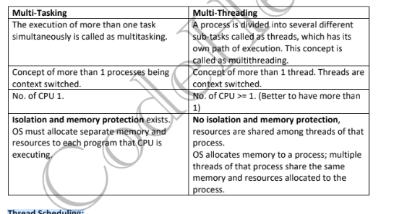

Thread Scheduling:

Threads are scheduled for execution based on their priority. Even though threads are

executing within the runtime, all threads are assigned processor time slices by the operating

system.

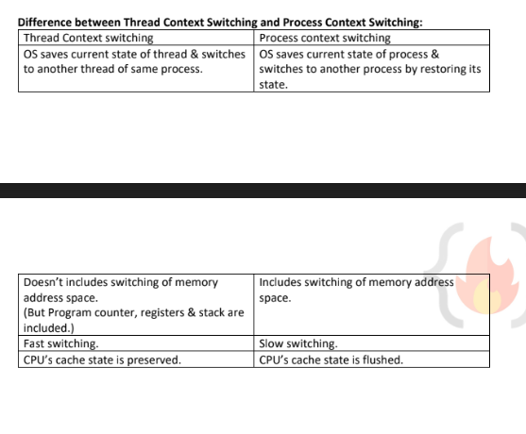

Cache - Faster than the RAM Memory.

It is accessible faster. Store the item or object which are required for the Process execution more frequently.